Please Join Us
for an Evening of Aloha and Inspiration
to Support the Best Day Foundation New Jersey Chapter

Featuring the "Ultimate Waterman"
Zane Kekoa Schweitzer

Sunday, September 17, 2017
6 pm - 9 pm
Last Wave Brewing Co.
601 Bay Avenue, Point Pleasant Beach, NJ
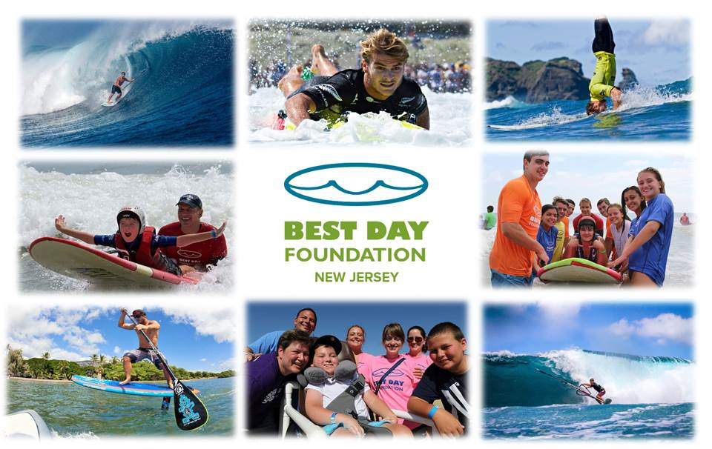

Enjoy live acoustic music, craft beer, appetizers, and silent auction.
Tickets
$15 per person over 21 years of age
$10 per person under 21 years of age

For more information and tickets visit: https://alohabenefitbestdaynj.eventbrite.com

All proceeds and donations are paid directly to Best Day Foundation to expand our programs to
ensure more children will have the opportunity to experience their “Best Day” ever.

Best Day Foundation is a 501(c)(3) volunteer based, non-profit organization that hosts adventure activities for youth with special needs. Tax-ID 26-2223078 www.bestdayfoundation.org

